**ЛАБОРАТОРНА РОБОТА № 6**

з дисципліни

«Розробка програмного забезпечення на Java»

Шейко Р. О.

Групи КІ-21-2

**Завдання на лабораторну роботу:**

1. Розробіть вищевказаний додаток.

2. За допомогою вищевказаного матеріалу зробіть базу даних з іншої предмет-ної області на ваш вибір та розробіть новий додаток для неї.

**Завдання 1**

Було завдання розробити додаток для BuildingCompany.

Було розроблено базу даних. 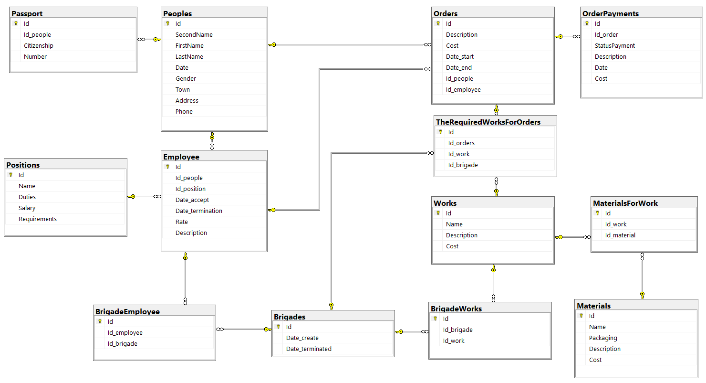

Покажу роботу з паспортом

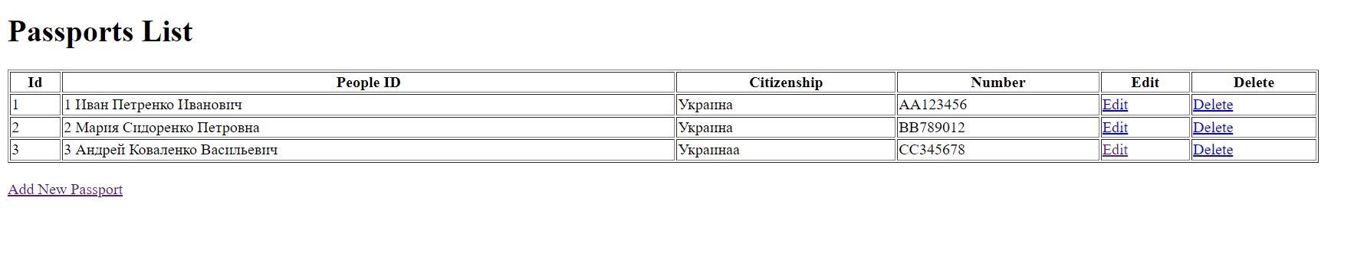

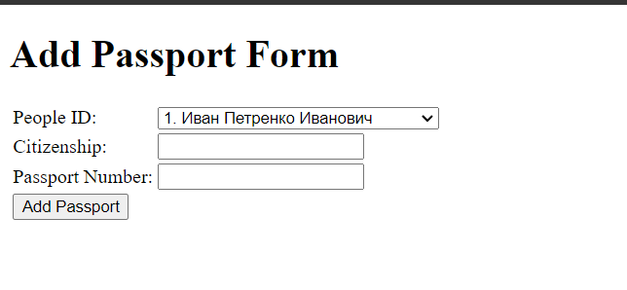

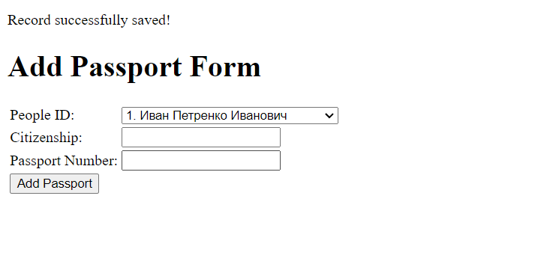

Додаємо інформацію

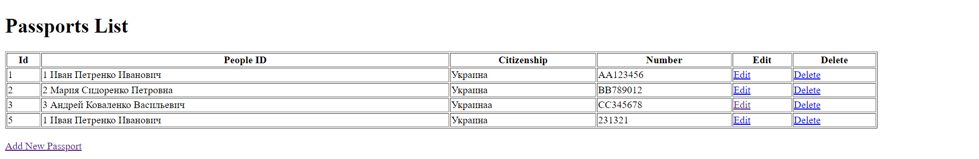

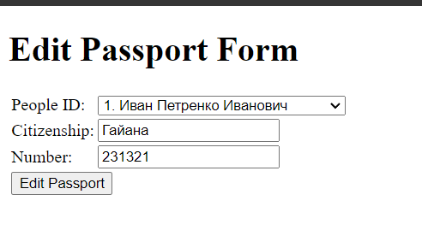

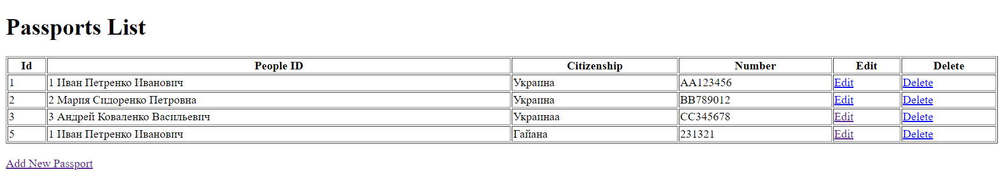

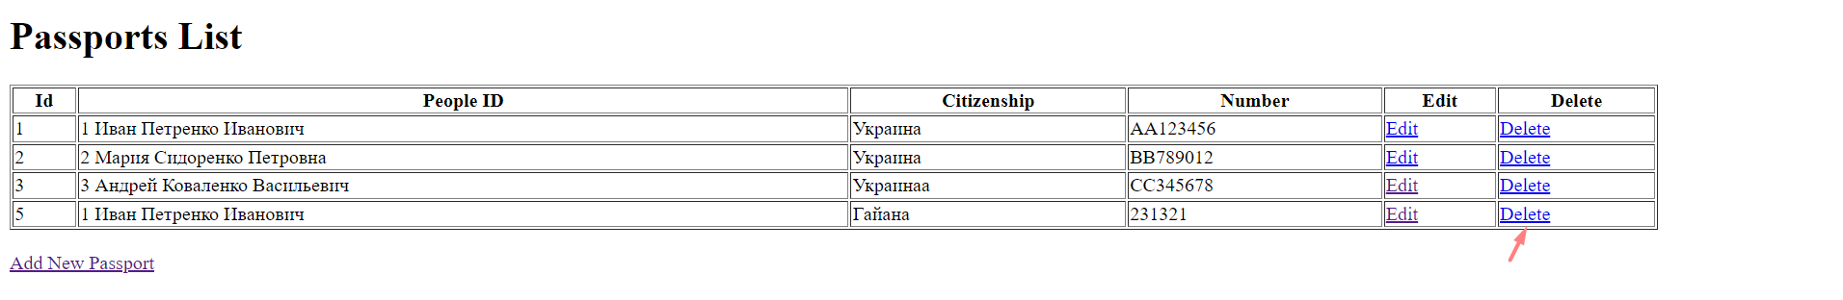

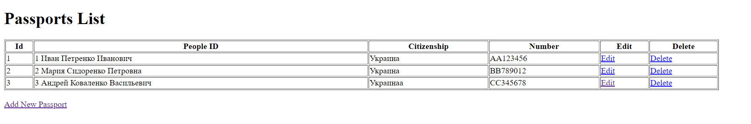

Приклад коду

addPassport.jsp

<%@ page contentType="text/html;charset=UTF-8" language="java" %>  
<%@ page import="com.example.bean.Passport, com.example.dao.PassportDao" %>  
  
<%  
 request.setCharacterEncoding("UTF-8");  
 Passport passport = new Passport();  
 passport.setId_people(Integer.*parseInt*(request.getParameter("id_people")));  
 passport.setCitizenship(request.getParameter("citizenship"));  
 passport.setNumber(request.getParameter("number"));  
  
 int i = PassportDao.*save*(passport);  
 if (i > 0) {  
 response.sendRedirect("addPassport-success.jsp");  
 } else {  
 response.sendRedirect("addPassport-error.jsp");  
 }  
%>

addPassport-error.jsp

<%@ page contentType="text/html;charset=UTF-8" language="java" %>  
<!DOCTYPE html>  
<html>  
<head>  
 <meta http-equiv="Content-Type" content="text/html; charset=ISO-8859-1">  
 <title>Add Passport Error</title></head>  
<body><p>Sorry, an error occurred!</p>  
<jsp:include page="addPassportForm.jsp"></jsp:include>  
</body>  
</html>

addPassport-success.jsp

<%@ page contentType="text/html;charset=UTF-8" %>  
<!DOCTYPE html>  
<html>  
<head>  
 <meta http-equiv="Content-Type" content="text/html; charset=ISO-8859-1">  
 <title>Add Passport Success</title></head>  
<body><p>Record successfully saved!</p>  
<jsp:include page="addPassportForm.jsp"></jsp:include>  
</body>  
</html>

addPassportForm.jsp

<%@ page import="com.example.bean.People.People" %>  
<%@ page import="java.util.List" %>  
<%@ page import="com.example.dao.PeopleDao" %>  
<%@ page contentType="text/html;charset=UTF-8" language="java" pageEncoding="UTF-8" %>  
<!DOCTYPE html>  
<html>  
<head>  
 <meta http-equiv="Content-Type" content="text/html; charset=UTF-8">  
 <title>Add Passport Form</title>  
</head>  
<body>  
<h1>Add Passport Form</h1>  
<form action="addPassport.jsp" method="post" accept-charset="UTF-8">  
 <table>  
 <tr>  
 <td>People ID:</td>  
 <td>  
 <select name="id_people">  
 <%  
 List<People> peopleList = PeopleDao.getAllRecords();  
 for (People person : peopleList) {  
 %>  
 <option value="<%= person.getId() %>"><%= person.getId() + ". " + person.getFirstName() + " " + person.getSecondName() + " " + person.getLastName() %>  
 </option>  
 <% } %>  
 </select>  
 </td>  
 </tr>  
 <tr>  
 <td>Citizenship:</td>  
 <td><input type="text" name="citizenship"/></td>  
 </tr>  
 <tr>  
 <td>Passport Number:</td>  
 <td><input type="text" name="number"/></td>  
 </tr>  
 <tr>  
 <td colspan="2"><input type="submit" value="Add Passport"/></td>  
 </tr>  
 </table>  
</form>  
</body>  
</html>

deletePassport.jsp

<%@ page contentType="text/html;charset=UTF-8" language="java" %>  
<%@ page import="com.example.dao.PassportDao" %>  
<jsp:useBean id="u" class="com.example.bean.Passport"></jsp:useBean>  
<jsp:setProperty property="*" name="u"/>  
<% PassportDao.*delete*(u);  
 response.sendRedirect("viewPassport.jsp"); %>

editPassport.jsp

<%@ page contentType="text/html;charset=UTF-8" language="java" %>  
<%@ page import="com.example.dao.PassportDao" %>  
<%@ page import="com.example.bean.Passport" %>  
<jsp:useBean id="u" class="com.example.bean.Passport"></jsp:useBean>  
  
<%  
 request.setCharacterEncoding("UTF-8");  
 String id = request.getParameter("id");  
 String id_people = request.getParameter("id_people");  
 String citizenship = request.getParameter("citizenship");  
 String number = request.getParameter("number");  
  
 u.setId(Integer.parseInt(id));  
 u.setId_people(Integer.parseInt(id_people));  
 u.setCitizenship(citizenship);  
 u.setNumber(number);  
  
 int i = PassportDao.update(u);  
 response.sendRedirect("viewPassport.jsp");  
%>  
EditPassportForm.jsp

<%@ page contentType="text/html;charset=UTF-8" language="java" pageEncoding="UTF-8" %>  
<%@ page import="com.example.bean.People.*" %>  
<%@ page import="com.example.dao.PeopleDao" %>  
<%@ page import="com.example.dao.PassportDao" %>  
<%@ page import="com.example.bean.Passport" %>  
<%@ page import="java.util.List" %>  
  
<%  
 String id = request.getParameter("id");  
 Passport passport = PassportDao.getRecordById(Integer.parseInt(id));  
%>  
  
<!DOCTYPE html>  
<html>  
<head>  
 <meta http-equiv="Content-Type" content="text/html; charset=UTF-8">  
 <title>Edit Passport Form</title>  
</head>  
<body>  
<h1>Edit Passport Form</h1>  
<form action="editPassport.jsp" method="post" accept-charset="UTF-8">  
 <input type="hidden" name="id" value="<%= passport.getId() %>"/>  
 <table>  
 <tr>  
 <td>People ID:</td>  
 <td>  
 <select name="id_people">  
 <%  
 List<People> peopleList = PeopleDao.getAllRecords();  
 for (People person : peopleList) {  
 %>  
 <option value="<%= person.getId() %>" <% if (person.getId() == passport.getId_people()) { %>  
 selected <% } %>><%=person.getId() + ". " + person.getFirstName() + " " + person.getSecondName() + " " + person.getLastName() %>  
 </option>  
 <% } %>  
 </select>  
 </td>  
 </tr>  
 <tr>  
 <td>Citizenship:</td>  
 <td><input type="text" name="citizenship" value="<%= passport.getCitizenship() %>"/></td>  
 </tr>  
 <tr>  
 <td>Number:</td>  
 <td><input type="text" name="number" value="<%= passport.getNumber() %>"/></td>  
 </tr>  
 <tr>  
 <td colspan="2"><input type="submit" value="Edit Passport"/></td>  
 </tr>  
 </table>  
</form>  
</body>  
</html>

ViewPassport.jsp

<%@ page contentType="text/html;charset=UTF-8" language="java" %>  
<!DOCTYPE html>  
<html>  
<head>  
 <meta http-equiv="Content-Type" content="text/html; charset=UTF-8">  
 <title>View Passports</title>  
</head>  
<body>  
<%@page import="com.example.dao.PassportDao, com.example.bean.Passport, java.util.List" %>  
<%@page import="com.example.bean.People.People"%>  
<%@page import="com.example.dao.PeopleDao"%>  
<h1>Passports List</h1>  
<%  
 List<Passport> passportList = PassportDao.getAllRecords();  
 List<People> peopleList = PeopleDao.getAllRecords();  
 request.setAttribute("passportList", passportList);  
 request.setAttribute("peopleList", peopleList);  
%>  
<table border="1" width="90%">  
 <tr>  
 <th>Id</th>  
 <th>People ID</th>  
 <th>Citizenship</th>  
 <th>Number</th>  
 <th>Edit</th>  
 <th>Delete</th>  
 </tr>  
 <% for (Passport passport : passportList) { %>  
 <tr>  
 <td><%= passport.getId() %></td>  
 <td><%= passport.getId_people() + " " + getPeopleName(peopleList, passport.getId_people()) %></td>  
 <td><%= passport.getCitizenship() %></td>  
 <td><%= passport.getNumber() %></td>  
 <td><a href="editPassportForm.jsp?id=<%= passport.getId() %>">Edit</a></td>  
 <td><a href="deletePassport.jsp?id=<%= passport.getId() %>">Delete</a></td>  
 </tr>  
 <% } %>  
</table>  
<br/><a href="addPassportForm.jsp">Add New Passport</a>  
<%!  
 public String getPeopleName(List<People> peopleList, int peopleId) {  
 for (People people : peopleList) {  
 if (people.getId() == peopleId) {  
 return people.getFirstName() + " " + people.getSecondName() + " " + people.getLastName();  
 }  
 }  
 return "";  
 }  
%>  
</body>  
</html>